**KATHFORD INTERNATIONAL COLLEGE OF ENGINEERING AND MANAGEMENT**

Balkumari, Lalitpur



A

Major Project Report

On

**“Image Processing based E-Attendance System”**

[Subject Code: EX755]

A

PROJECT REPORT

SUBMITTED TO THE DEPARTMENT OF COMPUTER AND

ELECTRONICS & COMMUNICATION ENGINEERING IN PARTIAL

FULFILMENT OF THE

REQUIREMENTS FOR THE DEGREE OF BACHELOR IN

ELECTRONICS & COMMUNICATION ENGINEERING

**Project Members**

Jenis Thapa (2073/BEX/06)

Madan Rijal Magar (2073/BEX/08)

Shree Krishna Dani Chhetri (2073/BEX/16)

**DEPARTMENT OF COMPUTER AND ELECTRONICS & COMMUNICATION ENGINEERING**

**LALITPUR, NEPAL**

**MARCH, 2021**

**KATHFORD INTERNATIONAL COLLEGE OF**

**ENGINEERING AND MANAGEMENT**

Balkumari, Lalitpur

(Affiliated to Tribhuvan University)

**“IMAGE PROCESSING BASED E-ATTENDANCE SYSTEM”**

A

PROJECT REPORT

SUBMITTED TO THE DEPARTMENT OF COMPUTER AND

ELECTRONICS & COMMUNICATION ENGINEERING IN PARTIAL

FULFILMENT OF THE

REQUIREMENTS FOR THE DEGREE OF BACHELOR IN

ELECTRONICS & COMMUNICATION ENGINEERING

**Submitted by:**

Jenis Thapa (2073/BEX/06)

Madan Rijal Magar (2073/BEX/08)

Shree Krishna Dani Chhetri (2073/BEX/16)

**Submitted To:**

DEPARTMENT OF COMPUTER AND ELECTRONICS &

COMMUNICATION ENGINEERING

MARCH, 2021

# COPYRIGHT

No part of this report can be copied without the permission of the authors. However, the authors have agreed that the Library, Department of Computer and Electronics & Communication, Kathford International College of Engineering and Management may take this project freely available for inspection. Moreover, authors have agreed that the permission for extensive copying of this project for scholarly purpose may be granted by the Professor(s), who supervised the project. It is understood that recognition will be given to the authors and to the department in any use of the parts of this project. Copying of publication or other use of this project for financial gain without approval of the department and author’s written permission is prohibited.

Request for permission to copy or to make any use of the material in this project in whole or part should be addressed to:

Head of the Department

Department of Computer and Electronics & Communication Engineering

Kathford International College of Engineering and Management

Balkumari, Lalitpur,

Nepal

MARCH, 2021

**TRIBHUWAN UNIVERSITY**

**KATHFORD INTERNATIONAL COLLEGE OF**

**ENGINEERING AND MANAGEMENT**

**DEPARTMENT OF COMPUTER AND ELECTRONICS &**

**COMMUNICATION ENGINEERING**

**Letter of Approval**

The undersigned certify that they have read and recommended to the Department of Computer and Electronics & Communication Engineering for acceptance, a project entitled **“Image processing based E-Attendance system”**, submitted by **Jenis Thapa,** **Madan Rijal Magar,**and **Shree Krishna Dani Chhetri** in partial fulfillment of the requirement for the minor project of **“Bachelor in Electronics and Communication Engineering”**.

External Examiner: Project Supervisor:

…………………… ………………………….

Er. Jitendra Ku. Manandhar Er. Saban Kumar KC

IOE, Pulchowk Campus Lecturer

Department of Computer and

Electronics Engineering

Kathford International College of

Engineering and Management

March, 2021



Balkumari, Lalitpur-8, Nepal

**Tel.:** +977-1-5201241/5201911

**Fax:** +977-1-5201899

G.P.O.Box: 23483, Kathmandu

**E-mail:** [info@kathford.edu.np](mailto:info@kathford.edu.np)

**Web:** www.kathford.edu.np

**DEPARTMENTAL ACCEPTANCE**

The project entitled “**Image Processing Based E-Attendance System**”, submitted by ***Jenis Thapa, Madan Rijal Magar and Shree Krishna Dani Chhetri*** in partial fulfillment of the requirement for the minor project in **“*Bachelor in Electronics and Communication Engineering*”** has been accepted as a bonfire record of work carried out by them in the department.

………………………….

**Er. Prabin Kumar Jha**

Deputy Head of the Department

Department of Computer and Electronics & Communication Engineering

Kathford International College of Engineering and Management

Balkumari, Lalitpur

Nepal

MARCH, 2021

# ACKNOWLEDGEMENT

We would like to acknowledge the guidance and constructive suggestions provided by

the teachers and individuals in course of the preparation of this report. We would like to express our sincere thanks to **Er. Saban Kumar KC**, Project Supervisor for his

assistance and help during the process.

We are also obliged to all the individuals and groups who have directly or indirectly

assisted in the preparation of this report, especially **Er. Bikal Adhikari**, **Er. Kiran Bagale and Er. Pawan Khadka** for providing the comments and assistance in preparing the report.

We extend our gratitude towards DHOD of Department of Electronics and Communication of Kathford International College of Engineering and

Management for providing us the opportunity and the required environment, support and help to do this project.

We would like to convey our thanks to all teaching and non-teaching staff members of Department of Computer and Electronics & Communication Department of Kathford Engineering College of Engineering and Management for their invaluable support and help throughout the project period.

Also, we would like to express our deep sense of gratitude to our beloved friends and family members who tried to encourage us while doing this project with their valuable suggestions to approach our goals. The entire team is thankful to all the peoples who have either directly or indirectly helped for the successful completion of the project.

Lastly, we would humbly welcome any suggestions and guidance for the improvement of this report.

Thank You.

# ABSTRACT

In recent trends industries, organizations and many companies are using personal identification strategies like finger print identification, RFID for tracking attendance and etc. Among of all these personal identification strategies face recognition is natural, less time taken and highly efficient one. It has several applications in attendance management systems and security systems. The main strategy is taking attendance in organizations, industries and etc. using face detection. A time period is settled for taking the attendance and after completion of time period attendance will directly stores into storage device mechanically without any human intervention. Raspberry pi 3 module is used in this system to achieve high speed of operation. Camera is interfaced to one USB port of raspberry pi 3. Local binary pattern histogram algorithm is used for face detection and recognition. The attendance will directly store in storage device like pen drive that is connected to one of the USB port of raspberry pi 3. The designed system is able to recognize the face of students and enter the student details in MS-excel file for the attendance purpose.

***Keywords***: ***Raspberry pi 3, Face detection, open CV, Camera, Image processing***

# TABLE OF CONTENTS

ACKNOWLEDGEMENT i

ABSTRACT ii

TABLE OF CONTENTS iii

LIST OF FIGURES v

LIST OF TABLES vi

ABBREVIATION vii

1.INTRODUCTION 1

1.1 Background 1

1.2 Problem Statements 1

1.3 Objectives 1

1.3.1 Main Objective 2

1.3.2 Specific Objectives 2

1.4 Scopes and Applications 2

2. LITERATURE REVIEW 3

3.PROJECT METHODOLOGY 5

3.1 Flow diagram of methodology adopted 5

3.2 Block diagram of the designed system 6

3.3 Flowchart of Designed System 7

3.3.1 Flow chart of system storing individual detail 7

3.3.2 Flow chart of system recognizing student detail 8

3.3.3 Facial Recognition system flow 9

3.4 Principle used in this project 10

3.4.1 Local Binary Pattern Histogram 10

4. HARDWARE AND SOFTWARE REQUIREMENT 11

4.1 Hardware Requirement 11

4.1.1 Raspberry pi 11

4.1.2 Pi Camera 13

4.2 Software Used 13

5. RESULTS AND DISCUSSION 14

5.1 Capturing the images of students using web-cam 14

5.2 Detection of the faces of students using linear binary pattern histogram algorithm 14

6. CONCLUSIONS 16

7. LIMITATION AND FUTURE ENHANCEMENT 17

7.1 Limitations 17

7.2 Future Enhancement 17

REFERENCES 18

APPENDIX A 19

APPENDIX B 21

# LIST OF FIGURES

Figure 1: Flow diagram of methodology adopted 5

Figure 2: Block Diagram of designed System 6

Figure 3: Flowchart of the System for storing details 7

Figure 4: flowchart of the system recognizing student details 8

Figure 5: Facial recognition system flow 9

Figure 6: figure of raspberry pi 11

Figure 7: figure of pi camera 13

Figure 8: capturing the images of student using web-cam 14

Figure 9: Detection of the faces of students using LBPH algorithm 14

Figure 10: storing the attendance in excel 15

Figure 11 stimulation for raspberry pi 3 19

Figure 12: Different dataset of the student 19

Figure 13:capturing the images of student using web-cam 20

Figure 14: capturing the images of student using web-cam 20

# LIST OF TABLES

Table 1: specification of raspberry pi3 12

Table 2 :Cost estimated 21

# ABBREVIATION

CPU: Central Processing Unit

SRAM: Static Random-Access Memory

PLC: Programmable Logic Controller

LBPH: Linear Binary Pattern Histogram

# 1.INTRODUCTION

## 1.1 Background

The present society comprises of highly efficient and effective methods to carry out the special or any other day to day task. Taking attendance is also one of the day to day task to any organization like school, colleges and office. The method applied to do attendance is quite primitive. Taking the name of students calling them reporting or entering data on the sheet is quite a tedious task and makes waste of time rather than this the system we propose will change the nature of taking attendance. The E-Attendance system will be done in a real time without wasting any time for calling names filling the sheet but it will be far more advance to recognize the faces of students or any other individual and letting the program do the tedious task. This will lead to have far more useful outcomes like saving time, getting the information in computers or desktops rather than sheet of papers which is more prone to physical hazards. A system recognizing face of students will be more futuristic as well, thus this system will help the organization from its tedious day to day task of taking attendance of filling the entry and they can be quite productive using this time.

## 1.2 Problem Statements

The existing attendance system is manual. It wastes a considerable amount of time both for teachers and students. The waiting time of the students is increased if attendance is taken manually. The larger the number of individual or the larger the organization more number of equipment required. In this way, there are following major issues in existing scenario such as:

* Time consuming manual attendance system
* Chances of human error and manipulation exist

In order to tackle these issues, an appropriate system is needed and we intend to design a face recognition based attendance system.

## 1.3 Objectives

Following are some main objective and specific objectives.

### 1.3.1 Main Objective

The main objective of this project is to design an image processing based e-attendance system.

### 1.3.2 Specific Objectives

* To capture the images of students using web-cam
* To detect the faces of students using linear binary pattern histogram algorithm
* To prepare the student details such as name, roll no. and date in MS-excel file

## 1.4 Scopes and Applications

These are the fields where this project can be used:

* This project can be extensively used in the places where the frequent requirement of attendance is necessary.
* This project can be used to recognize the personnel belonging to a group or an organization

# 2. LITERATURE REVIEW

In organizations, industries and many companies are taking the entire attendance using RFID methods [1], registers, Moodle based student ID identification [2], and fingerprint modules [3]. In registers, the entire attendance will be calculated and reports will be gathered at the end. It takes more time for calculation.

RFID technology [4]. simplifies programmed wireless using digital passive and active with identifications appropriate readers. In short duration, worth’s of diffusion and implementation for an RFID card-based fare cluster system can be rather expensive. An RFID based fare cluster system has the potential of seriously violating human’s security or privacy. RFID strategies ultimately effects software that allows each person to be analyzed by primary data base. This type of environment will be under attack of hackers. If the RFID reader and receiver are not properly matched then less read rate can occurs.

Biometric time and presence system [5],is one of the most accurate requirements in biometric technology. Fingerprint recognition based attendance management system is a running field today, but recognition of individual fingerprint from a set of enrolled fingerprints is a time taking process. Most fingerprint-based attendance systems store the finger prints of a user in the fingerprint module database. The fingerprint system does not reveal any data about the original fingerprint of the user. This assumption has now been shown to be false; many algorithms [6], have been stated that can restore fingerprint images from minutiae templates. These biometric systems, RFID systems and Moodle based student ID identification systems are personal identification systems used for attendance management systems and many security systems. In ensuing days for any systems security, privacy and accuracy are mainly calculating parameters but these systems are violating security and inaccurate. So, it is important to design a system with highly secured and accurate.

This face recognition [7] based attendance management system with raspberry pi 2 using Eigen faces algorithm is high secured, highly efficient and accurate. The module espies the images of student’s face captured by the camera, which have been catalogued manually with their names and ID codes in the system database. Face detection data and face recognition data are stored into the system database. Using the stored database, all the details like date, time and present or absentee is calculated and message will be sent to absentee student parents using GSM technology. Let us Assume that a person framed in any random captures not an attendee at the Renaissance Fair, the system can be assumed that the face is not in color space like white red green or any unnatural color. With the assumption of a typical captured scenario, it would be clear to take an advantage of face-color correlations to limit our face search to areas of an image that have at least the correct color components. To achieving this goal, we looked forward at three color spaces HSV spaces, YCrCb spaces and RGB space. RGB (red, green, and blue) is the frequently used basis for color characterizations. Using this color characterizations system will understand difference from human and nonhuman faces. The background of the image also one of main effect [8], using this image-based system. If the intensity of the background light is high system accuracy decreases. So, it is important to place the system in correct area. The system identifies the images of student’s face, which have been stored manually with their names and ID codes in the database. This system is mainly useful for organizations to take period wise attendance also by setting the time period. An application is created to capture the images, storing ID numbers, starting recognition process, time period and file generation with attendance details. This paper explains about methodology, system overview, implementation and conclusion of the system.

.

# 3.PROJECT METHODOLOGY

## 3.1 Flow diagram of methodology adopted

Problem Statements

Literature Review

Scheduling & Budgeting

Design

Selection of components & software

Coding and stimulation

Testing

Documentation

Figure 1: Flow diagram of methodology adopted

## 3.2 Block diagram of the designed system

Raspberry Pi 3

Camera Module

Power Supply

Excel-storage

Desktop-PC

Figure 2: Block Diagram of designed System

Raspberry Pi will be main brain of the system as microcontroller. The Camera Module will connect to it so that we can take the image for processing and storing. The Rasbian Software will install in it through memory card and Raspberry pi will connected to the laptop or desktop for user interface. There will be Excel Sheet for storing the image and do attendance system. Our approach will five modules – Face Detection, Face Preprocessing, Face Training, Face Recognition and Attendance Database. The face database is collected to recognize the faces of the students.

## 3.3 Flowchart of Designed System

### 3.3.1 Flow chart of system storing individual detail

Crop The Face

Image processing

Assign Student detail

Store in database

Take a photo

Figure 3: Flowchart of the System for storing details

Initially the camera stores the data of student and create a dataset along with the student detail including name roll number, then the data is stored in the database for the further recognizing purpose.

### 3.3.2 Flow chart of system recognizing student detail

Crop The Face

Match with student detail

Image processing

Take attendance

YES

NO

Take a photo

Figure 4: flowchart of the system recognizing student details

In this process the student face is detected from the video and the the student details is matched and the attendance is taken.

### 3.3.3 Facial Recognition system flow

Training database(image)

Face Detection

Face alignment

Feature extraction(LBPH)

Data set

Face comparision

Face extraction

Face alignment



Face extraction



Figure 5: Facial recognition system flow

This is the facial recognition system flow where the process taken in the facial detection is given we use Binary Linear Pattern Algorithm thus the face data is stored and using the same algorithm the face is recognized and then the student detail is matched.

## 3.4 Principle used in this project

### 3.4.1 Local Binary Pattern Histogram

LBPH is a simple yet very efficient texture operator which labels the pixels of an image by thresholding the neighbourhood of each pixel and considers the result as a binary number. Local Binary Pattern Histogram summarize the local structure in an image by comparing each pixel with its neighbourhood. It takes a pixel as centre and threshold its neighbours against. If the intensity of the centre pixel is greater-equal its neighbour, then denote it with 1 and 0 if not.

# 4. HARDWARE AND SOFTWARE REQUIREMENT

## 4.1 Hardware Requirement

Following are the hardware required for this project:

* Raspberry pi
* Pi camera

### 4**.1.1 Raspberry pi**

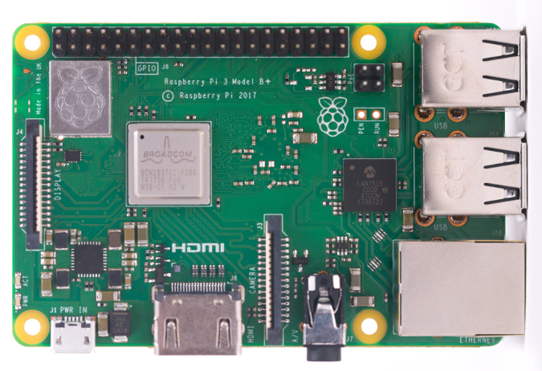

Figure 6: figure of raspberry pi

*[source: https://www.elektor.com/raspberry-pi-3-model-a-plus]*

|  |  |
| --- | --- |
| Microprocessor | Broadcom BCM2837 64bit Quad Core Processor |
| Processor Operating Voltage | 3.3V |
| Raw Voltage input | 5V, 2A power source |
| Maximum current through each I/O pin | 16mA |
| Maximum total current drawn from all I/O pins | 54mA |
| Flash Memory (Operating System) | 16Gbytes SSD memory card |
| Internal RAM | 1Gbytes DDR2 |
| Clock Frequency | 1.2GHz |
| GPU | Dual Core Video Core IV® Multimedia Co-Processor. Provides Open GLES 2.0, hardware-accelerated Open VG, and 1080p30 H.264 high- profile decode.  Capable of 1Gpixel/s, 1.5Gtexel/s or 24GFLOPs with texture filtering and DMA infrastructure. |
| Ethernet | 10/100 Ethernet |
| Wireless Connectivity | BCM43143 (802.11 b/g/n Wireless LAN and Bluetooth 4.1) |
| Operating Temperature | -40ºC to +85ºC |

Table 1: specification of raspberry pi3

### 4.1.2 Pi Camera

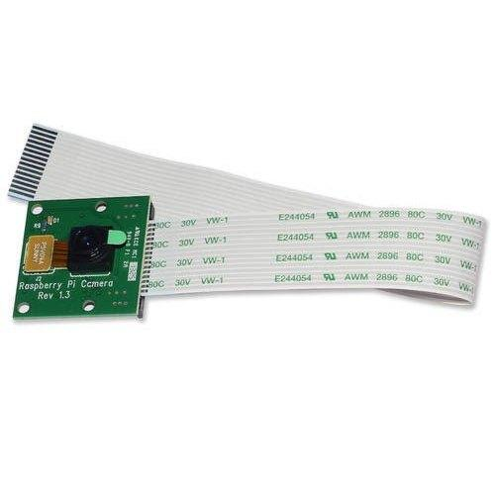

Figure 7: figure of pi camera

*[Source:* [*https://www.buyapi.ca/product/raspberry-pi-8mp-camera-board-v2/*](https://www.buyapi.ca/product/raspberry-pi-8mp-camera-board-v2/)*]*

* 5MP color camera module without microphone for Raspberry pi
* Supports both raspberry pi model A and B
* MIPI camera serial interface
* Omni vision 5647 camera module
* Resolution: 2592*1944
* Supports 1090 p,720 p and 480p
* Light weight and portable

## 4.2 Software Used

* Python
* Visual studio
* Microsoft excel
* Raspbion

# 5. RESULTS AND DISCUSSION

## 5.1 Capturing the images of students using web-cam

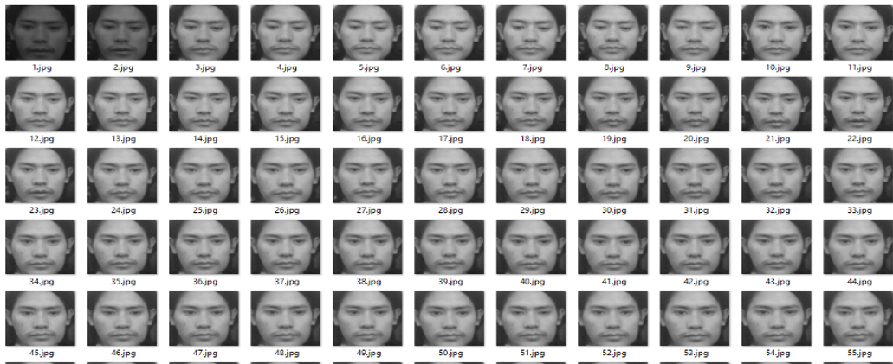

Figure 8: capturing the images of student using web-cam

Here, when the student is faced toward the camera module-web-cam. The module captures 100 photos in total and trains the dataset to fill up the student detail for the further purpose of taking the attendance.

## 5.2 Detection of the faces of students using linear binary pattern histogram algorithm

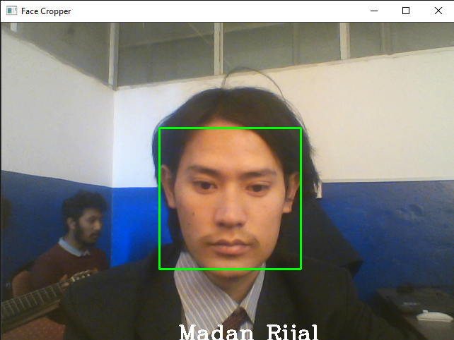

Figure 9: Detection of the faces of students using LBPH algorithm

The LBPH algorithm recognizes the student face through the dataset created and provides the student name in the screen where as it gives .CSV file which can be opened in MS-Excel

**5.3 Result for displaying attendance**



Figure 10: storing the attendance in excel

# 6. CONCLUSIONS

During the completion of this project we studied and got knowledge about the processor like raspberry pi, pi camera module & different software like visual studio python, raspbion OS. The project was completed and we were able to capture the images of students using web-cam, detect the faces of students using linear binary pattern histogram algorithm and finally prepare the student details such as name, roll no. and date in MS-excel file.

# 7. LIMITATION AND FUTURE ENHANCEMENT

## 7.1 Limitations

The system has following limitation:

* This system is limited to few students dataset.
* The data is registered only on MS-Excel sheet.

## 7.2 Future Enhancement

In the future, we mean to add several features to this project which are as follow:

* The details of multiple student a time can be taken.
* Real time security can be added.
* The web-server can be used.

# REFERENCES

|  |  |
| --- | --- |
| [1] | T. Fac, A. Keroh and S. Malaysia, "RFID based attendance system," 2009. |
| [2] | T. Usagawa, N. Yuhei and C. Yoshifumi , "attendance management systen for moodle using student identification card and android device," 2014. |
| [3] | L. Quan-Xi and L. Gang M, "An Efficient Automatic Attendance System using fingerprint Reconstruction," International journal of computer science and information technology. |
| [4] | K. R.Yamamoto and P. G. Flikemma, "RFID-Based Students Attendance Management," International journal of scientific and research center,2011. |
| [5] | U. E. peter and N. Owerri , "Opera biometric based attendance system with remote real time monitoring," 2013. |
| [6] | "Design and implementation of iris based attendance management system electrical engineering and information communication technologies," 2015. |
| [7] | "Automated attendance management system based on face recognixation algorithm computational intelligence and computing research," in international conference , 2013. |
| [8] | Y.-M. Lu, N. Kaohsiung and . L. Bin-Yih, "A face recognizing algorithm decreasing the illuminating effect intelligent information hiding and multimedia signal processing," 2008. |

# APPENDIX A

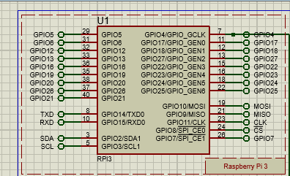

Figure 11 stimulation for raspberry pi 3

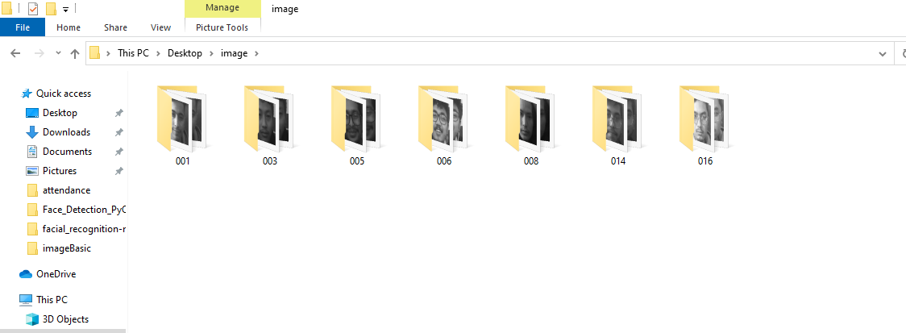

Figure 12: Different dataset of the student

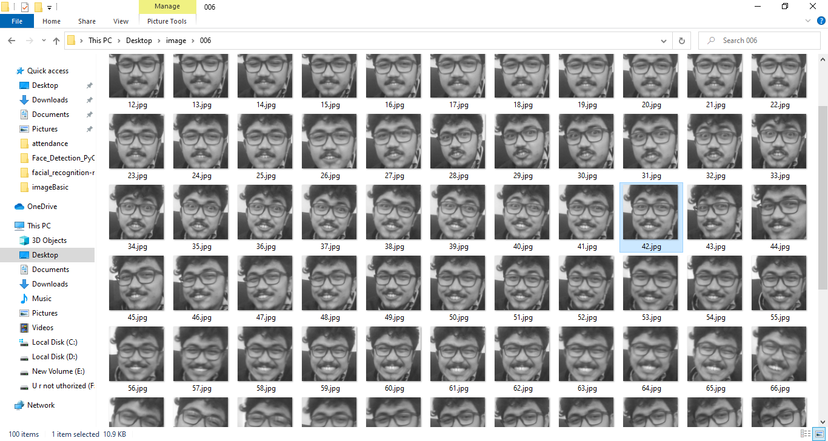

Figure 13:capturing the images of student using web-cam

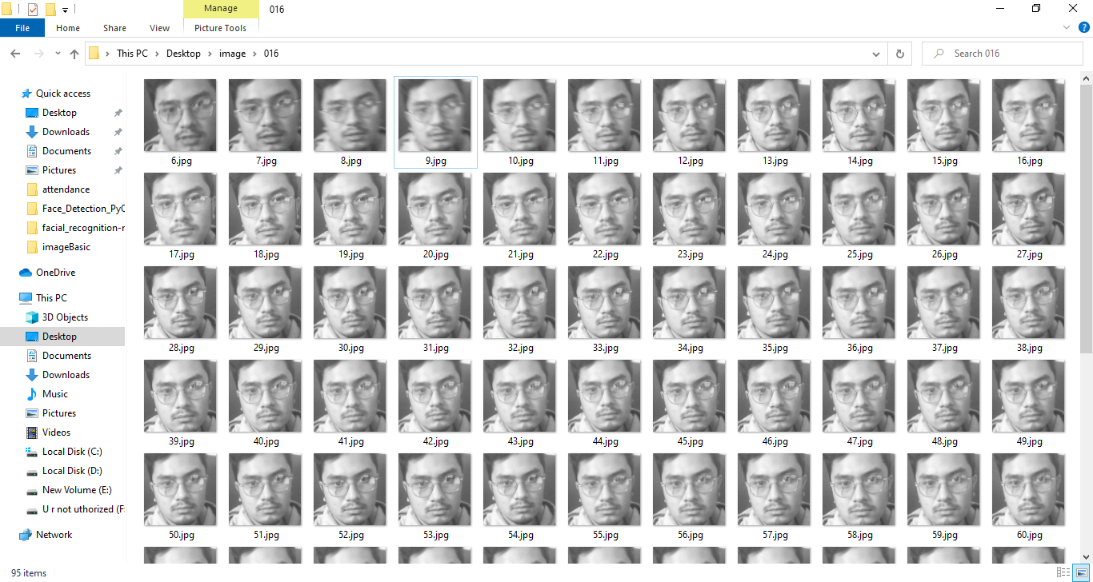

Figure 14: capturing the images of student using web-cam

# APPENDIX B



**Table 2 :Cost estimated**